AITO winners of the prestigious 2015
Travel Writer of the Year Awards announced

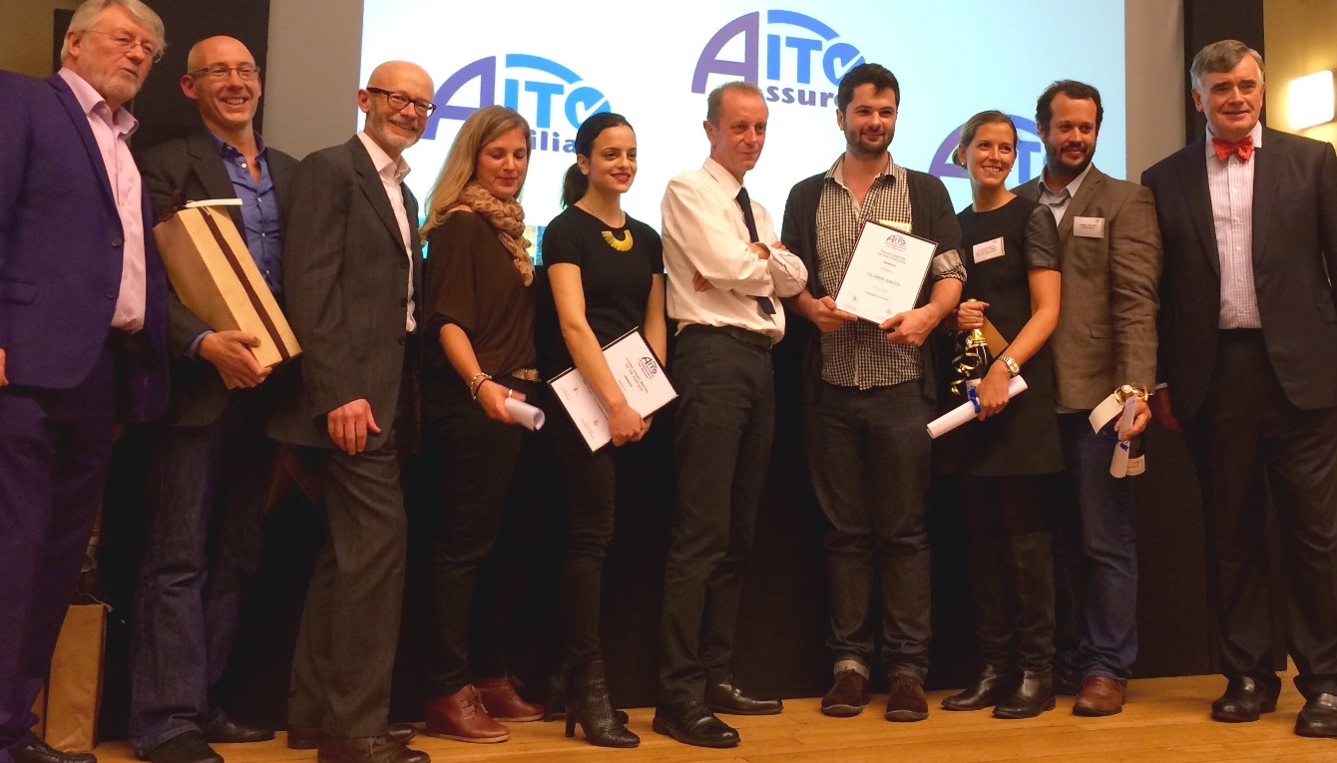

Photo caption (left to right): Winners and presenters of the AITO Travel Writer of the Year Awards
Derek Moore (AITO’s Chair), Peter Sommer (Peter Sommer Travels Ltd), Mark Hodson (101 Holidays), Sarah Barrell collecting on behalf of Zoë McIntyre (National Geographic Traveller), Maria Alafouzou (SUITCASE magazine), Stephen Bleach (The Sunday Times), Oliver Smith (Lonely Planet Traveller), Katie Bowman collecting on behalf of Laura Goodman (The Sunday Times Travel Magazine), James Draven (Dearly Departures), Christopher Kirker (Kirker Holidays and former AITO Chair).

25 November 2015

AITO has announced the results of its 19th Travel Writer of the Year awards. This year saw the highest number of entries since the awards began in 1997, with 228 articles submitted, all of an exceptionally high standard. The categories were Travel Writer of the Year, Young Travel Writer of the Year and AITO Travel Blogger of the Year. The awards were presented at the AITO Meets the Media event held at Central Hall Westminster on 24 November.

AITO Travel Writer of the Year

This award is always extremely hotly contested and, over the past 19 years, some of the most respected travel journalists in the industry have featured on the roll of honour (see below). It recognises excellence in the huge field of travel writing, and this prestigious award is always an impressive entry on any writer’s CV. This year, the top five writers were extremely close – just two points between the winner and number five.

For the second year running, the winner of the AITO Travel Writer of the Year 2015 award was Oliver Smith, for his Lonely Planet Traveller article on Oman called ‘Nothing to see here’. One judge said it was “an excellent, well-written piece, full of atmosphere and Arabian nights”. Another said: “I kept reading extracts to my wife. I really liked the humanity of the piece”. Oliver seems to have something of a track record with the AITO Travel Writer awards. In 2010, he won the Young Travel Writer of the Year award. In 2012 and again last year he won the Travel Writer of the Year Award and now he’s capped it with a fourth win for Lonely Planet Traveller. One judge said “Oliver consistently writes exceptionally good travel pieces; this is certainly the equal of many of his other articles.”

In second place, by the smallest of margins, was Stephen Bleach for his Sunday Times piece on Greece called ‘Sailing – The Idiot’s Guide’. One of the judges said “it was written with brio and skill – I liked it a lot”. Another judge said “it was a charming piece about a family holiday – the dad telling porkies to get the sailing holiday he wanted. It’s amusingly written and made the judge smile wryly many times. It was a lovely reminder of the importance of the shared memories of a family holiday that are so valuable.”

In third place, was Mike Carter, with his article in The Financial Times, on Mongolia called ‘Where Eagles Hunt’. One judge said the piece was “hugely descriptive of a life that bears no resemblance whatsoever to ours and was packed with experiences a-plenty.”

AITO Young Travel Writer of the Year

This award celebrates travel writing talent in the under-30s. It was a very large and interesting field of entries and the judges found it challenging to select the overall winner. One judge mentioned how enormously impressed he was with the younger category this year. He said there was some fine writing, which he found very encouraging indeed.

The winner of Young Travel Writer of the Year was Maria Alafouzou, for her SUITCASE magazine article called ‘Eden Project – The Galapagos Islands’. It was “a very different, very thoughtful take on the Galapagos from someone who ended up thinking that perhaps she should not have visited for environmental reasons.” One judge commented: “The Galapagos is a frequent travel article topic, but this was a pleasing mixture of wildlife details blended with a clear concern for the environmental impact of the very wildlife the author was enjoying.” Another commented: “Outstanding: an informed, witty narrative that brings colonial life to a crucial sustainability debate.”

In second place was Zoë McIntyre for her piece in National Geographic Traveller on Bolivia called ‘Into the Bolivian backwaters’, which conveyed a serious message about the Bolivian Government’s plan to flood unexplored areas of the Amazon basin. The judges said how “it was lightly and yet very interestingly written”. One judge said “he was hurled straight into the jungle – what an excellent piece.”

In third place was Laura Goodman for her piece in The Sunday Times Travel Magazine on Brittany, called ‘Sweet ‘n’ salty’. It was felt that Laura included a very good level of detail, interesting facts and extremely helpful reminders and prompts throughout the article as she toured Brittany in search of the key tastes of the region. One judge said: “This is exactly my sort of holiday – take me there now!”

AITO Travel Blogger of the Year

This category was a category introduced two years ago, to recognise the increasing influence of travel bloggers and their role within the travel writing community.

The winner of AITO’s Travel Blogger of the Year award was Emma Gregg for her piece ‘Smooth waters: narrow boating on the Monmouthshire and Brecon Canal’ in the blog All About Everywhere. One judge said how persuasive it was and that it really made him want to go on a canal holiday. He added that “a wryly humorous feel runs through the piece as we follow the author being gradually won over to the idea of narrow boating.” Another judge commented how “absorbing” the article was. He said “I was with Emma all the way on her boat journey. It unexpectedly made me want to return to canal boating; fluid and enjoyable.”

In second place was Mark Hodson for his blog in 101 Holidays called ‘Is Seville the sexiest city in Europe?’ One judge said it “really tickled the tastebuds” and another said “there was great pace and it was a very enjoyable read indeed.”

In third place was James Draven for his piece ‘Swimming with sharks in South Australia’ in the blog Dearly Departures. The judges said it was “a very interesting topic, which included some fascinating facts about cage diving with sharks, the damage caused to the animals when they attack the cages and how they could be attracted by playing underwater music rather than enticed by blood and guts.”

The Chairman of AITO, Derek Moore, said: “Huge congratulations to all of the entrants for such a high standard this year. We saw a record number of entries, with the AITO Travel Writer of the Year category proving particularly impressive this year. The top 10 articles were incredibly close indeed.

“As usual, it’s been a mammoth but very interesting exercise for the judges – so many carefully-crafted articles, so many fascinating destinations visited, and such a brilliant demonstration of how vividly words can bring a place to life and drive demand to visit a destination, even if there are disasters and tragedies.

“AITO will be 40 years old in 2016 and we look forward to receiving an excellent array of entries in our important milestone year.”

AITO welcomes one entry per person for its Travel Writer of the Year Awards, and encourages travel editors to enter pieces that have been published on their pages or their sites during the course of the next 12 months.

For further information, visit www.aito.com.

-Ends-

Notes to editors:

Shortlisted from a total of over 228 entries, the names of those who scored highest are as follows:

The top 10 places for the AITO Travel Writer of the Year award 2015 were as follows:

- Oliver Smith, Lonely Planet Traveller
- Stephen Bleach, The Sunday Times
- Mike Carter, The Financial Times
- Duncan Craig, The Lonely Planet Traveller Magazine
- Judy Armstrong, France magazine
- Peter Browne, Condé Nast magazine
- Steve Boggan, British Airways’ High Life Magazine
- Tom Chesshyre, The Times
- Kerry Christiani, Adventure Travel magazine
- Ian Belcher, The Times
Martin Hemming, The Sunday Times (joint 10th place)

The top five places for the AITO Young Travel Writer of the Year award 2015 were as follows:

- Maria Alafouzou, SUITCASE magazine
- Zoë McIntyre, National Geographic Traveller
- Laura Goodman, The Sunday Times Travel Magazine
- Faris Mustafa, British Airways’ High Life Magazine
- Ben Clatworthy, The Times

The top five places for the AITO Travel Blogger of the Year award 2015 are as follows:

- Emma Gregg, All About Everywhere
- Mark Hodson, 101 Holidays
- James Draven, Dearly Departures
- Adrian Phillips, National Geographic Traveller blog
- Kerri Christiani, Lonely Planet Magazine

A warm thank you to everyone who entered the AITO Travel Writer of the Year awards, and many congratulations to all the winners.

The list of past and present winners in full:

The AITO Travel Writer of the Year award - celebrating 19 years of excellence in travel writing

2015 Oliver Smith (Lonely Planet Traveller)
2014 Oliver Smith (Lonely Planet Traveller)
2013 Mark Jones (BA High Life)
2012 Oliver Smith (Lonely Planet Traveller)
2011 Stephen Bleach (The Sunday Times)
2010 Stephen Bleach (The Sunday Times)
2009 Minty Clinch (FT/How to Spend It magazine)
2008 Chris Haslam (The Sunday Times)
2007 Peter Hughes (The Daily Telegraph)
2006 Chris Haslam (The Sunday Times)
2005 Nigel Tisdall (Ultratravel Magazine, The Daily Telegraph)
2004 Brian Jackman (The Daily Telegraph)
2003 Peter Hughes (The Daily Telegraph)
2002 William Gray (Wanderlust)
2001 Matt Rudd and Stephen Bleach (joint winners – The Sunday Times)
2000 Max Anderson (The Sunday Times)
1999 Jane Bussman (The Mail on Sunday)
1998 David Wickers (The Sunday Times)
1997 Jill Crawshaw (The Times and The Independent on Sunday)

AITO Young Travel Writer of the Year award

2015 Maria Alafouzou (SUITCASE magazine)
2014 Laura Goodman (The Sunday Times Travel magazine)
2013 Alasdair Baverstock (The Daily Telegraph)
2012 Rory Goulding (Lonely Planet Traveller)
2011 Nick Boulos (Wanderlust)
2010 Oliver Smith (Lonely Planet Traveller)

AITO Blogger of the Year Award

2015 Emma Gregg (All About Everywhere)
2014 Mark Hodson (101 Holidays)
2013 Charlie Walker (Charlie Walker Explore)

Press: For further information on AITO, please contact Travel PR on 020 8891 4440 or email Rebecca Milne (r.milne@travelpr.co.uk) or Sue Ockwell (s.ockwell@travelpr.co.uk).

