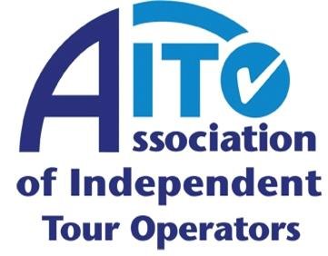

AITO TRAVEL WRITER OF THE YEAR SHORT LIST ANNOUNCED

The Association of Independent Tour Operators (AITO) today announces the short list for its prestigious annual AITO Travel Writer of the Year awards. The three award categories – Travel Writer of the Year, Young Travel Writer of the Year and the Travel Blogger of the Year – were chosen from a total of 228 entries, which is the highest received since the awards started, in 1997.

To find out who has been shortlisted, please click here.

The winners will be announced, and the awards presented, at this year’s AITO Meets the Media event, held between 3pm and 6pm on Tuesday 24 November at Central Hall, Westminster. If you would like to attend, please RSVP to events@travelpr.co.uk by 6pm on Friday 13 November 2015.

Bona fide journalists who have not yet received an invitation to attend AITO’s Meet the Media event are welcome to apply for an invitation, quoting their usual outlets and interests, by emailing Rebecca Milne at events@travelpr.co.uk.

Thank you to everyone who entered the AITO Travel Writer of the Year awards. Entries were of an extremely high standard, and the competition for places on the short list was more intense than ever. Good luck to those shortlisted!

For further information, visit www.aito.com.

Ends/ 27 October 2015

Press: For further information on AITO, please contact Travel PR on 020 8891 4440 or email Rebecca Milne (r.milne@travelpr.co.uk) or Sue Ockwell (s.ockwell@travelpr.co.uk).

