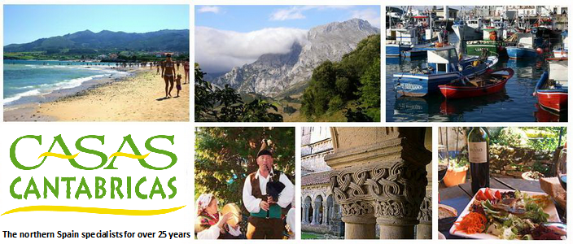

Two exciting news items from Casas Cantabricas

1. The BIG guide to Northern Spain – Travel App

[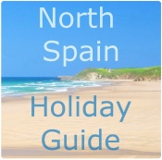](http://www.casas.co.uk/north-spain-holiday-guide)We’ve now released our full Northern Spain Holiday Guide with **over 1000 POIs**.

Freely available on-line and directly embedded in our website so clients can understand the region and plan ahead, the app contains a wealth of knowledge built up **over 30 years** in the Northern provinces. It also includes all the content from our **Restaurant Guide** which we’ve built up over the years – over 250 restaurants!

[Description: https://gallery.mailchimp.com/476dee0d319094b0899403b61/images/3032d202-5190-456d-b21d-16bc1ffdff0b.png](https://itunes.apple.com/en/app/north-spain-holiday-guide/id896681771?l=en&mt=8)          [Description: https://gallery.mailchimp.com/476dee0d319094b0899403b61/images/78133cd1-b295-4b3f-874b-5cac9969ac86.png](https://play.google.com/store/apps/details?id=com.northspain.U5666601139437568A4722539880251392)       [Description: https://gallery.mailchimp.com/476dee0d319094b0899403b61/images/eb9c284a-4729-4150-9bbe-fc6f79eb5198.png](http://www.casas.co.uk/north-spain-holiday-guide)

1. New - Villas with Pools

We’ve been working hard to further upgrade our villa accommodation. We’ve created a [Premier Selection](http://www.casas.co.uk/villas-in-northern-spain?keyword=&region=&location=&type=selfcatering&sleeping=6&premierSelection=on&arriving=&departing=&flexBefore=&flexAfter=&pageid=2#searchFilter) category and have added a good many [villas with pools](http://www.casas.co.uk/villa-pool-galicia), mostly in south-west Galicia where the benign micro-climate favours that style of holiday.

Earlier in the year we totally overhauled our website to help showcase the properties with better images and a much improved **local guide section on each property** which in turn links up with the embedded app

